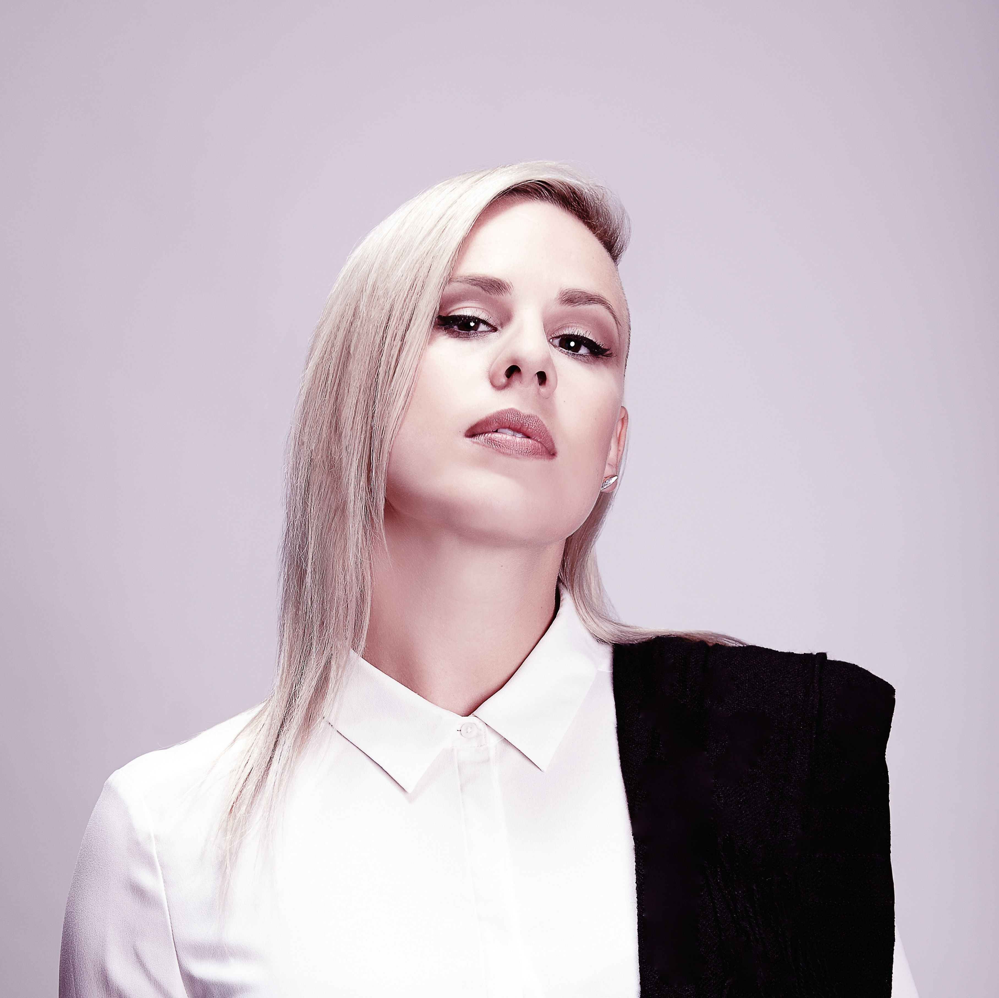

**Genre:** Neo Soul |Future-Soul

**For Fans Of**

Erykah Badu, Jill Scott, Jose James, The Internet, Mary J Blige, Moloko & N’dea Davenport.

**Solo Releases:**

LUMINOUS Album (SSR, 2016)

GING Remix EP (BBE Records, 2016)

Rising One EP (BBE Records, 2015)

Sacha Vee EP (Rhythm Method, 2011)

**Watch:**

[SACHA VEE PROMO VIDEO](https://youtu.be/nlR-AK9Oueg)

**Performs Solo or with Band:**

MPK249 Beat machine /Abelton Setup

**Social Links**

[www.sachavee.com](http://www.sachavee.com)

<https://www.youtube.com/c/SachaVee>

<https://soundcloud.com/sachaveemusic>

<https://instagram.com/sachaveemusic>

<https://www.facebook.com/sachaveemusic>

<https://twitter.com/sachaveemusic>

**Bookings & info Contact:**

[mgmt@sachavee.com](mailto:mgmt@sachavee.com)

**Press Contact:**

[nicole@nicnakmedia.com](mailto:nicole@nicnakmedia.com)

**ARTIST - SACHA VEE**

Over 30 Million youtube views, 2 x double platinum and 1 x Gold albums, international releases on BBE Records (UK), Roche Musique(FR), SELECTED(DE) & Sweet Soul Records (JP). Over 25 International collaborations, a finalist on the Voice of Holland, 3 solo releases including album Luminous 2016 which charted at No.3 on the NZ Heatseeker Charts, recent support slots for Jhene Aiko & G-Eazy and countless international performances in front audiences up to 20,000.

New Zealand born neo-soul singer, Sacha Vee is someone to know of, both as a respected artist and as a songwriter.

# Key Selling Points

* Sacha’s collaborations with Polish hip-hop artist O.S.T.R. have gone 3 x Platinum, won ‘Hip Hop album of the year’ (Fryderyki 2017, Poland) and garnered over 20 million YouTube views.
* Recently finished playing international shows in Tokyo, Paris, Amsterdam, Los Angeles & Canada for Luminous album tour.
* Successful features with Jengi Beats ‘Without You’ & with Wantigga ‘Stonecold’.
* Songwriter for Downtown Music Publishing (DMP)

**Whats others have said;**

*"Very Badu indeed…’GING' got it going on.”*

**Mi-Soul Radio (UK)**

*“‘HeavyLoad’ is one of the best rnb tracks Ive heard in years. Right up there with Mary J Blige…if not better”*

**O.S.T.R (Polish MC)**

*"When I heard her song ‘Hey Sugar’ I knew I needed to work with this girl..”*

**Charlie 2na (Jarassic 5)**

*"Great voice. Looking forward to the full length album.”*

**Eavesdrop Radio WKDU (Philadelphia)**

*"Her vocals are effortless, mellow and warm…a very strong debut EP.”*

**Kara Segedin,** **NZ Musician Magazine.**

[Luminous Album Review](http://www.apple.com)

*“This album is worthy of NZ music awards and global stardom. An outstanding and compelling album, which is highly addictive.”*